**Presentation Notes:**

1. What are the four functions of a computer program listed on the lesson slide?
   1. A Computer Program controls the hardware of a computer system.
   2. It makes decisions about how Input Devices   
      affect Output Devices
   3. Changing the program changes the function   
      of the computer hardware
   4. Computer Programs control more than just traditional computer systems

1. Provide an example of a computer input that is not listed on the lesson slide.

An example of a computer input that is not listed on the slide is a usb drive.

1. Provide an example of a computer output that is not listed on the lesson slide.

A printer is a output device that is not listed in the slides

1. Provide another example of how a computer input affects a computer output that is not listed on the lesson slide.

You can use a usb drive to upload files to a computer then print them using a printer

1. Provide an example of how changing the program changes how computer inputs affect computer outputs that is not listed on the lesson slide.

Changing the binds of a controller on a ps4 can change what the button does in a game

1. What are some examples of devices that are not traditional computers but that make use of computer programs?
   1. Simon game
   2. phones
   3. toy cars
   4. Ps4
2. Provide another example of a device that makes use of a computer program that is not listed on the lesson slide.

Toys or toy cars, voice mails

1. What is another term for a computer program?

Computer programs are also known as computer software.

1. What are some ways that computer software is different from computer hardware?

Software uses logic and is easily changed while hardware uses physical devices and is hard to change.

1. How are computer programs written?

Computer programs are written plane text. Are created using keyboard and editor.

1. Why are computer programs composed of many lines of computer code?

The lines are tiny text that are used a commands. (each line does a simple thing, to have a complicated thing you must a lines of simple things.)

1. List some examples of different computer languages.
   1. C/C+
   2. Java
   3. COBOL/SQL
   4. Python
2. List some of the benefits of the Python computer language.
   1. Is a professional language
   2. Is good for prototyping small programs
   3. It is a good beginner language
   4. It is the language of choice for 1st year of university courses
3. Once you finish this course, how could you answer someone who asks you "Do you know how to program in Java?"

Yes, I know how to write programs and picking up java will take some time but I could learn it.

1. Could you use Microsoft Word to write a computer program? Explain.

You could but it wouldn’t be a good idea, Microsoft word is not efficient and is optimized for writing .

1. What does IDE stand for?

Integrated Development Environment

1. What are some features of an Integrated Development Environment?
   1. Color coding of keywords
   2. Indentation and completion control
   3. Error checking
   4. Runtime support and debugging.

1. What are some factors to consider when choosing an Integrated Development Environment?
   1. How well does it support your language?
   2. Is it web-based or download install
   3. Other factors
2. What is the name of the IDE that we will be using to create our Python programs?

Repl.it

1. What version of Python will we be using?

Python not python v2

1. Draw a sketch of the Repl interface showing the three work areas (panels)
   1. Label each panel
   2. Summarize the function of each panel

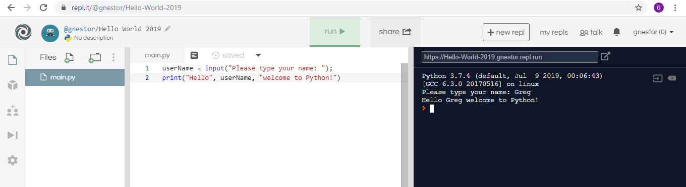

**Student Questions:**

1. Create an account for yourself at www.repl.it
   1. Review the "Terms of Service" to verify that you can legally use this service.
   2. Follow the previous discussed guidelines regarding use of personal information
2. List the part of the "Terms of Service" that verifies that you can legally use this service.

Your access to and use of the Service is conditioned upon your acceptance of and compliance with these Terms. These Terms apply to all visitors, users and others who wish to access or use the Service.

1. Explain some of the rights that you give away to Repl.it regarding content you create using their service? If you wish to purchase any product or service made available through the Service ("Purchase"), you may be asked to supply certain information relevant to your Purchase including, without limitation, your credit card number, the expiration date of your credit card, your billing address, your shipping information and CSC number.
2. Create a new Python repl and call it "Hello World".
3. Copy and paste the following program into the program panel (white area)

userName = input("Please type your name: ");

print("Hello", userName, "welcome to Python!")

1. Run the program to see what it does. (If necessary, fix the quotation marks so it runs properly.)
   1. Explain how the program works: input means what the person should put for the print text to appear and when you put a name and press enter it prints the text.
   2. Explain how you fixed the program (if necessary)
2. Try using the console pane (black area) to perform some simple calculations and run some one-line programs.
   1. Summarize some of your calculations.
3. Try using the file management pane to add some files and folders to your repl.
   1. Summarize some of your additions.